Lab Assignment: SHA-512 & HMAC and File Integrity Verification
Name- Harshit Kumar More
Roll No. - 16

Task 8: SHA-512 Hash and HMAC Implementation
1. Write a Python program to compute SHA-512 hash of a file.
2. Display the hash value in hexadecimal format.
import hashlib
with open("file.txt", "rb") as f:
data = f.read()
hash_val = hashlib.sha512(data).hexdigest()
print("SHA-512 Hash:")
print(hash_val)
Hash Value:
3. Generate a secret key and compute HMAC using SHA-512.
import hmac
key = b'secret_key'
hmac_val = hmac.new(key, data, hashlib.sha512).hexdigest()
print("\nHMAC (SHA-512):")
print(hmac_val)

Output:
4. Modify the file and recompute hash and HMAC.
with open("file.txt", "a") as f:
f.write("\nFile has been modified!")
with open("file.txt", "rb") as f:
new_data = f.read()
new_hash = hashlib.sha512(new_data).hexdigest()
new_hmac = hmac.new(key, new_data, hashlib.sha512).hexdigest()
print("\nNew SHA-512 Hash:")
print(new_hash)
print("\nNew HMAC:")
print(new_hmac)
Output:
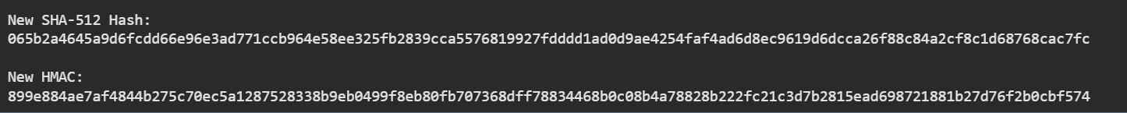
5. Compare results and observe changes.
print("\nComparison Result:")

if hash_val == new_hash:
print("Hash unchanged")
else:
print("Hash changed → File Tampered")

if hmac_val == new_hmac:
print("HMAC unchanged")
else:
print("HMAC changed → File Tampered")

Output:
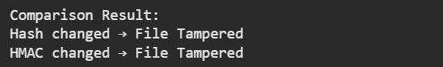

Task 9: File Integrity Verification
Define Hash Function
import hashlib

def get_hash(file):
with open(file, 'rb') as f:
return hashlib.sha512(f.read()).hexdigest()

Store Original Hash
original_hash = get_hash("file.txt") #STORE Original Hash

Recompute After Some Time
current_hash = get_hash("file.txt")

Compare Hashes
if original_hash == current_hash:
print("Integrity Verified")
else:
print("Integrity Compromised")

Output:

